**Web Technology with**

**UI/UX**

**Task-1: Create a GIT repository named as your enrollment number. Create 2 folders in your repository named as Assignment_1 and Assignment_2.**

**Prepare a word file which contains each step of this task.**

**Upload your assignments in the respective folder. Share your git repository link in a google form asked to you at the time of submission.**

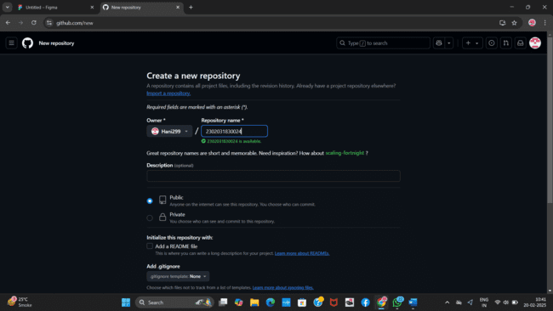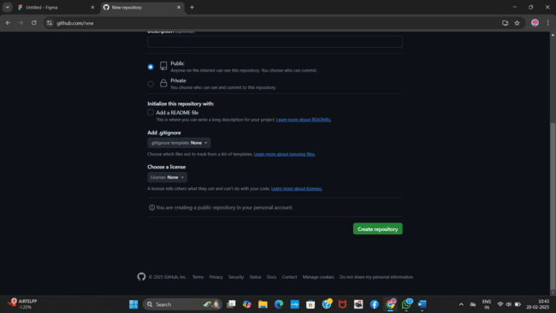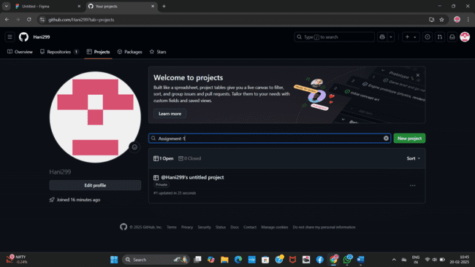

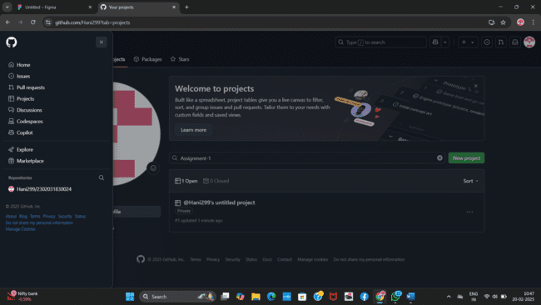

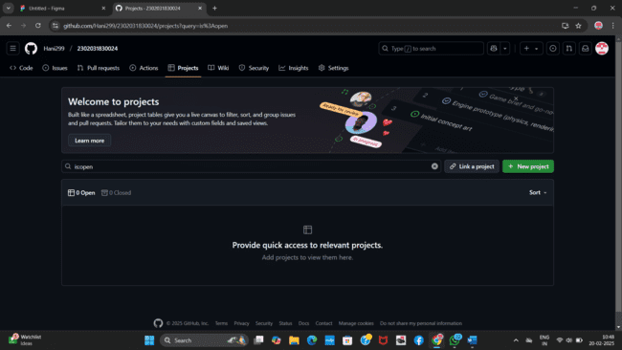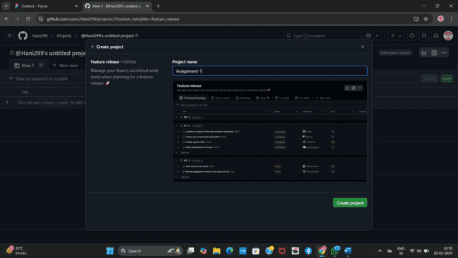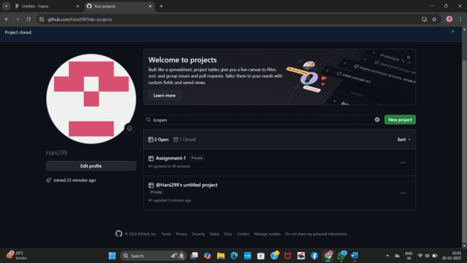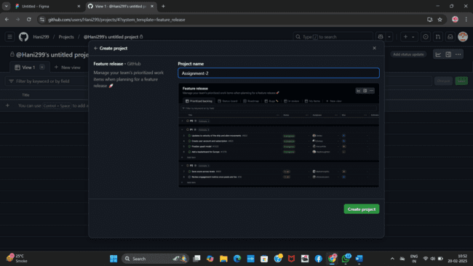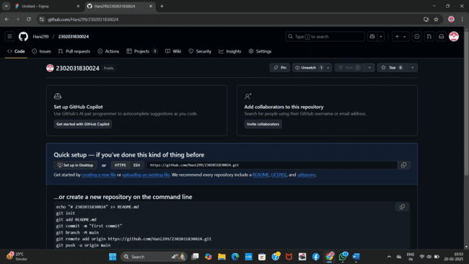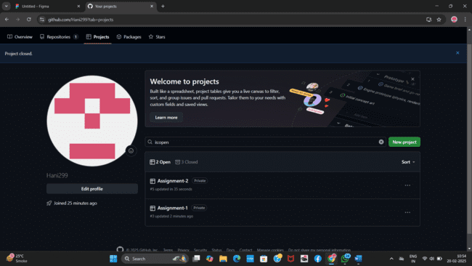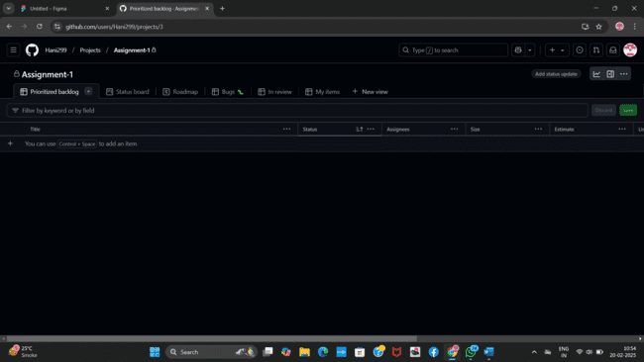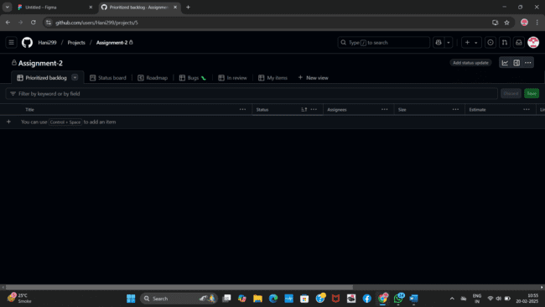

**Guided By -**

**Mr. JayKumar Gandharva**

**Prepared By -**

**Hani Shingala**

**2302031830024**

**4CE_D_057**